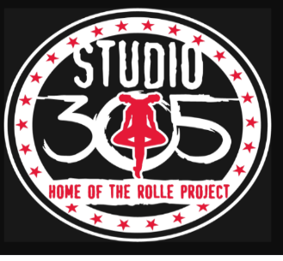

**Studio 305 Class Schedule Fall Aug 12-May 24,2025**

**Single Class $100 One Day combo classes $150 monthly Two days $200 monthly**

**Three Days $250 monthly *Competition Team $300 monthly Unlimited w solo practice $395**

**(All classes are Based on skill level and age)**

**Monday *Subject to change**

|  |  |
| --- | --- |
| **Emeralds * Beginners Level 1+**  **Ages 6-9yrs*Mr.Tyrell**  Ballet 5:00-6:00pm  Acro/Hip Hop 6:00-7:00pm  Rehearsal 7:00-7:30pm  Studio 150 | **Munchkins Combo Class \***  **Ages 3-5yrs Mrs. Tiffany**  Creative Ballet 5:00-6:00pm  Hip Hop/Pom 6:00-6:50pm  Studio 150 (B) |

**Tuesday *Subject to change**

|  |  |
| --- | --- |
| **Pearls* Competition Team**  **Ages 9-12yrs *Ms.Makenna**  Ballet 5-6:30pm  Pre-Pointe -6:30-7:00pm  Hip Hop 7:00-8:00pm  Studio 150 | **Munchkin Acro *Mr.T/DJ**  **Ages 3-5yrs**  Acro Fundamentals 5:00-6:00pm  Studio 150 (B) |

**Wednesday *Subject to change**

|  |  |
| --- | --- |
| **Pre-Teen/Teens (Artist N Training)**  **Int/Advance Ages 11 & UP *Mrs.Cassa**  Ballet 5:00-6:30pm  Pre-Pointe -6:30-7pm  Repertory 7:00-8:00pm  Studio 150 | **Boys Hip Hop * Open Class**  Hip Hop 6:30-7:30pm  Studio 150 (B) Starting in September |

**Thursday *Subject to change**

|  |  |
| --- | --- |
| **\* Emeralds * Level 2+**  **Ages 7-10yrs *Mr.Crystion**  Ballet 5:00-6:00pm  Hip Hop 6:00-7:00pm  **Hip Hop 11 & Up 7:00-8:00pm**  Studio 150 | **Munchkins Combo Class *Ms.Neisha**  **Ages 3-5yrs**  Creative Movement 5:00-6:00pm  Studio 150 (B) |

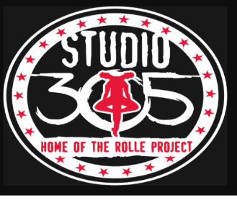

**Studio 305 Class Schedule Fall Aug 12-May 24,2025**

**Single Class $100 One Day combo classes $150 monthly Two days $200 monthly**

**Three Days $250 monthly *Competition Team $300 monthly Unlimited w solo practice $395**

**(All classes are Based on skill level and age)**

**Friday *Subject to change**

|  |  |
| --- | --- |
| **\* Battle Squads Teams *Coach Greg/Tyrell**  **Ages 5 & Up (ALL TEAMS)**  Warm Up 5:00-6:00pm  Repertory 6:00-7:00pm  Repertory 7:00-7:30pm  Studio 150  *Select Fridays see calendar | **Mini Battle Team**  **Ages 5-9yrs**  Warm Up 5:00-6:00pm  Studio 150 (B) |

**Saturday *Subject to change**

|  |  |
| --- | --- |
| **Munchkins Creative Dance**  **Ms. Kijai**  **Ages 5-6yrs**  9-9:55am  Studio 150 (B)  **Munchkins Hip Hop**  **Mrs. Tiffany/Kijai**  **Ages 3-6yrs**  10-11:00am  Studio 150  **\*Emeralds Ballet/Horton/Repertory**  **Ms.E & Mr.T & Ms.Neisha**  11:00-12:30pm  **Artist N Training/TRP**  **12:30-1:30pm Class ages 9-17yrs**  **1:30-3pm Pearls, P2, PE**  **Rolle Project Ensemble 2-4p** | **Munchkins Ballet w Mrs. Tiffany**  **Ages 3-4yrs**  **9-9:50am**  Studio 150 (B)  **P2**  **Office Duties/TA 10-12pm**  **Studio 150** |